Day 15 - 05th Aug 2026

Task 1:
What is angular? Explain briefly.
9.35 to 9.40

Task 2:
What is data binding? Explain.
How many types of data bindings do you have .. can you explain them.
9.41 to 9.45

Task 3:
Why do you need Angular? Can you give some advantages of using angular with description.
9.46 to 9.50

Task 4;
What is Rest API?
9.51 to 9.54

Task 5:
Why do we use Rest API?
9.55 to 9.58

Task 6:
What are single Page Applications?
9.59 to 10.05

Task 7:
Explain modules, components and services in Angular.
10.06 to 10.10

Task 8:
In data binding can you explain Property Binding ,Event Binding, String Interpolation, Two way data binding
10.11 to 10.16

Task 9:
What
Are decorators? Explain types of decorators.
10.17 to 10.22

Task 10:
What are annotations in angular?
10.23 to 10.26
Task 11:
In the below code snippet what are we doing .. can you explain..

// parent component
import { Component } from '@angular/core';
@Component({
selector: 'app-parent',
template: `
<app-child [childMessage]="parentMessage"></app-child>
`,
styleUrls: ['./parent.component.css']
})
export class ParentComponent{
parentMessage = "message from parent"
constructor() { }
}
// child component
import { Component, Input } from '@angular/core';
@Component({
selector: 'app-child',
template: `Say {{ childMessage }}`,
styleUrls: ['./child.component.css']
})
export class ChildComponent {
@Input() childMessage: string;
constructor() { }
}

10.27 to 10.31

Task 12:
Can you create a typescript class with a constructor and a function.
10.32 to 10.35

Task 13:
There is something called eager loading. What do you mean by eager and lazy loading?
10.36 to 10.40

Task 14:
What is an observable response?
12.50 to 12.55
Task 15:
What is the flow of your Angular project.. Explain with an ex.
12.56 to 1.00

1.00 to 2.00 lunch break

Complete tasks by 2.08 to 2.15

This is my expected output

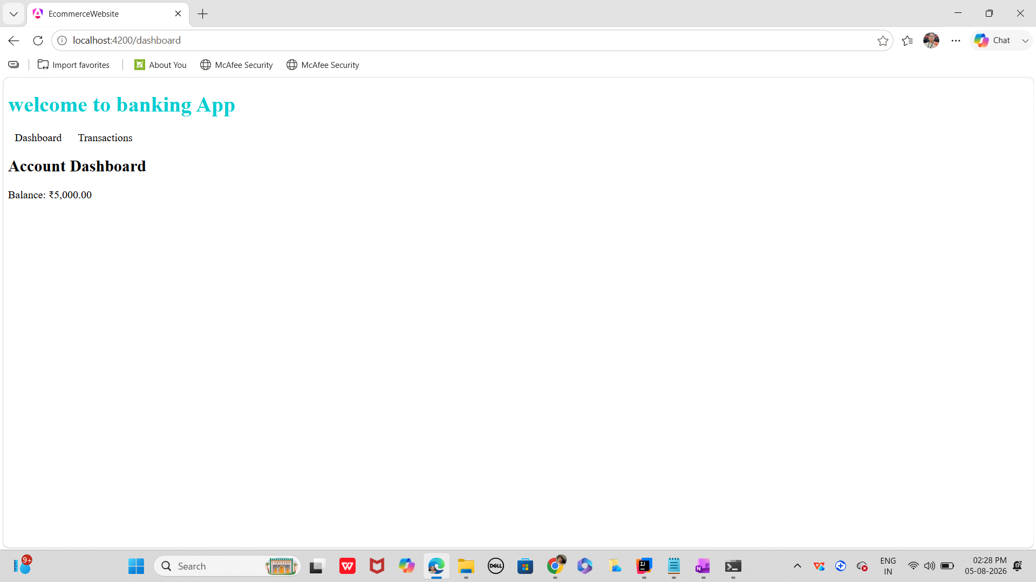

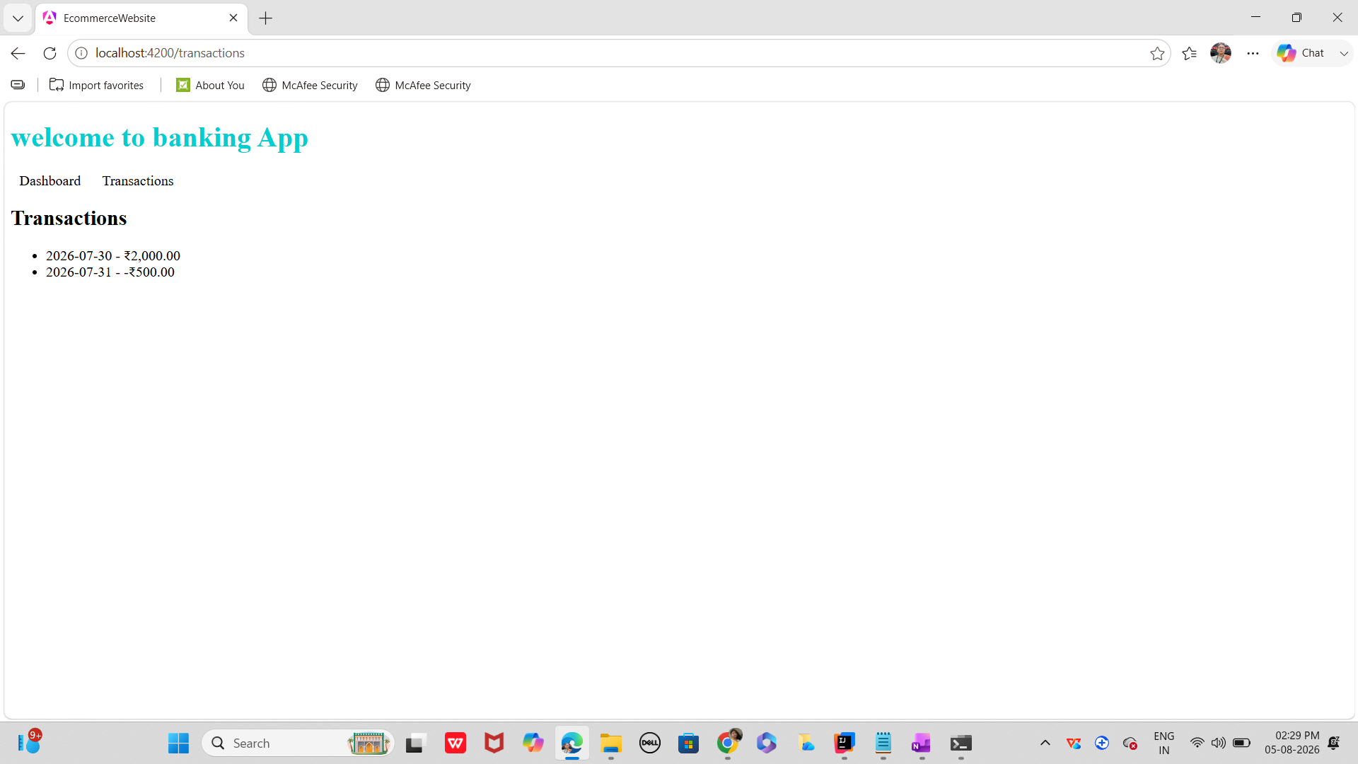

main.ts

import { bootstrapApplication } from '@angular/platform-browser';
import { appConfig } from './app/app.config';
import { AppComponent } from './app/app.component';

bootstrapApplication(AppComponent, appConfig)
.catch((err) => console.error(err));

app.component.ts

import {Component, signal} from '@angular/core';
import {RouterOutlet} from '@angular/router';

@Component({
selector: 'app-root',
standalone: true,
imports: [RouterOutlet],
templateUrl: './app.component.html',
styleUrls: ['./app.component.css'],
})

export class AppComponent{
protected readonly title =signal('my-angular-app03');
}

Dashboard.component.ts

import { Component } from '@angular/core';
import { CurrencyPipe } from '@angular/common';

@Component({
selector: 'app-dashboard',
standalone: true,
imports: [CurrencyPipe],
template: `
<h2>Account Dashboard</h2>
<p>Balance: {{ balance | currency: 'INR' }}</p>
`,
})
export class DashboardComponent {
balance: number = 5000;
}

Transaction.compnent.ts

import { Component } from '@angular/core';
import { NgFor, NgIf, CurrencyPipe } from '@angular/common';
@Component({
selector: 'app-transactions',
standalone: true,
imports: [NgFor, NgIf, CurrencyPipe],
template: `
<h2>Transactions</h2>
<ul>
<li *ngFor="let txn of transactions">{{ txn.date }} - {{ txn.amount | currency: 'INR' }}</li>
</ul>
<p *ngIf="transactions.length === 0">No transactions found.</p>
`,
})
export class TransactionsComponent {
transactions = [
{ date: '2026-07-30', amount: 2000 },
{ date: '2026-07-31', amount: -500 },
];
}

app.routes.ts

import { Routes } from '@angular/router';
import { DashboardComponent } from './dashboard.component';
import { TransactionsComponent } from './transactions.component';

export const routes: Routes = [
{ path: 'dashboard', component: DashboardComponent },
{ path: 'transactions', component: TransactionsComponent },
{ path: '', redirectTo: '/dashboard', pathMatch: 'full' },
];

App.component.html

<h1>welcome to banking App</h1>
<nav>
<a routerLink = "/dashboard">Dashboard </a>
<a routerLink="/transactions">Transactions </a>
</nav>
<router-outlet></router-outlet>

App.component.css

h1 {
color: darkturquoise;
}
nav a{
margin: 0 10px;
}

Index.html

<!doctype html>
<html lang="en">
<head>
<meta charset="utf-8">
<title>EcommerceWebsite</title>
<base href="/">
<meta name="viewport" content="width=device-width, initial-scale=1">
<link rel="icon" type="image/x-icon" href="favicon.ico">
</head>
<body>
<app-root></app-root>
</body>
</html>

Task 16:

Create a fundtransfer.service.ts

Services & Dependency Injection in Angular
in service layer
Encapsulate business logic (e.g., fund transfers, notifications).
so that it promote reusability across multiple components.
and will also enable loose coupling by separating logic from UI.

In my file fundtransfer.service.ts sample

import { Injectable } from '@angular/core';

@Injectable({
providedIn: 'root', // Singleton service available app-wide
})
export class FundTransferService {
transferFunds(fromAccount: string, toAccount: string, amount: number): string {
if (amount <= 0) {
return 'Invalid transfer amount';
}
// Business logic (simplified)
return `₹${amount} transferred from ${fromAccount} to ${toAccount}`;
}
}

Now inject the above service in to the component. — transfer.component.ts

import { Component } from '@angular/core';
import { FundTransferService } from './fund-transfer.service';

@Component({
selector: 'app-transfer',
template: `
<h2>Fund Transfer</h2>
<button (click)="doTransfer()">Transfer ₹500</button>
<p>{{ message }}</p>
`,
})
export class TransferComponent {
message: string = '';

constructor(private transferService: FundTransferService) {}

doTransfer() {
this.message = this.transferService.transferFunds('Account A', 'Account B', 500);
}
}

Try adding one more service notification.service.ts

import { Injectable } from '@angular/core';

@Injectable({
providedIn: 'root',
})
export class NotificationService {
notifyUser(message: string) {
console.log('Notification:', message);
}
}

Now you need to update you fundtransfer.service.ts

@Injectable({
providedIn: 'root'
})
export class FundTransferService {
constructor(private notificationService: NotificationService) {}

transferFunds(fromAccount: string, toAccount: string, amount: number): string {
const result = `₹${amount} transferred from ${fromAccount} to ${toAccount}`;
this.notificationService.notifyUser(result);
return result;
}
}

Task of the day:

create a form component… say loginform.

Validation ensures users don’t transfer less than ₹100.
You can add async validators (e.g., check if account exists via API).
🔹 Advanced Features
FormArray → For multiple beneficiaries.
Custom Validators → e.g., prevent transfer to the same account.
Async Validators → e.g., check account balance before transfer.
Dynamic Forms → Add/remove fields at runtime.

—------------------------------------------------------------------------------------------------------------------

